**SIR APOLLO KAGGWA SCHOOLS**

**MID TERM II - 2024**

**PRIMARY FOUR**

**INTEGRATED SCIENCE**

***Time allowed: 2 hours 15 minutes***

**Name: ______________________________________________________________**

**School: _____________________________________________________________**

**FOR EXAMINER’S USE ONLY**

**Read the following instructions carefully:**

1. The paper has **two** sections: **A** and **B**
2. Section **A** has 40 questions (40 marks)

**FOR EXAMINER’S USE ONLY**

|  |  |  |
| --- | --- | --- |
| **Qn. No** | **MARK** | **SIGN** |
| **1 – 10** |  |  |
| **11 – 20** |  |  |
| **21 – 30** |  |  |
| **31 – 40** |  |  |
| **41 – 43** |  |  |
| **44 – 46** |  |  |
| **47 – 49** |  |  |
| **50 – 52** |  |  |
| **53 – 55** |  |  |
| **TOTAL** |  |  |

1. Section **B** has 15 questions (60 marks)
2. Answer **ALL** questions. All answers to both Sections **A**

and **B** must be written in the spaces provided.

1. All answers must be written using a blue or black ball

point pen or ink. Diagrams should be drawn in pencil.

1. Unnecessary crossing of work may lead to loss of marks.
2. Any handwriting that cannot be easily read may lead to

loss of marks.

1. Do **not** fill anything in the boxes indicated;

For Examiner’s use only.

***Turn over***

**SECTION A**

1. Name the instrument that is used to measure human body temperature.

________________________________________________________________________

2. Give any one item used to maintain personal hygiene.

________________________________________________________________________

3. Mention one example of a non-living thing.

________________________________________________________________________

4. How does a chameleon protect itself from enemies?

________________________________________________________________________

________________________________________________________________________

5. Give any one difference between animals and plants.

________________________________________________________________________

________________________________________________________________________

6. Which part of a seed develops into the shoot system?

________________________________________________________________________

7. Of what importance is a fire extinguisher in your school?

________________________________________________________________________

________________________________________________________________________

8. Mention one activity done on a health parade.

________________________________________________________________________

________________________________________________________________________

9. Name one disease spread by a housefly.

________________________________________________________________________

10. Why does a millipede coil itself when touched?

________________________________________________________________________

________________________________________________________________________

11. How important are nimbus clouds to a farmer?

­­­­­­­­­­­­­­­­­­­­­­­­­­­­­­­­­­­­­­­­­­­­________________________________________________________________________

________________________________________________________________________

12. Why should people wash hands with soap after visiting the toilet?

________________________________________________________________________

________________________________________________________________________

13. Name one crop whose leaves are eaten.

________________________________________________________________________

14. How are gills useful to a mushroom?

________________________________________________________________________

________________________________________________________________________

15. Which part of a flower attracts pollinators like insects?

________________________________________________________________________

16. Name the type of leaf venation shown in the diagram below.



________________________________________________________________________

17. How do fungi reproduce?

________________________________________________________________________

________________________________________________________________________

18. Why do bees visit flowers?

________________________________________________________________________

________________________________________________________________________

19. Which food value is got from eating fruits?

________________________________________________________________________

________________________________________________________________________

20. Mention one way a water source can be made dirty.

________________________________________________________________________

________________________________________________________________________

21. Identify one sign of dehydration in children.

________________________________________________________________________

________________________________________________________________________

22. Name the breathing organs for insects.

________________________________________________________________________

________________________________________________________________________

23. Write P.H.C in full.

________________________________________________________________________

________________________________________________________________________

24. Give a reason why we should smoke pit latrines.

________________________________________________________________________

________________________________________________________________________

25. Give one reason why animals move from one place to another.

________________________________________________________________________

________________________________________________________________________

26. Identify one way of caring for crops in the garden.

________________________________________________________________________

________________________________________________________________________

27. Which property of air is shown in the diagram below?

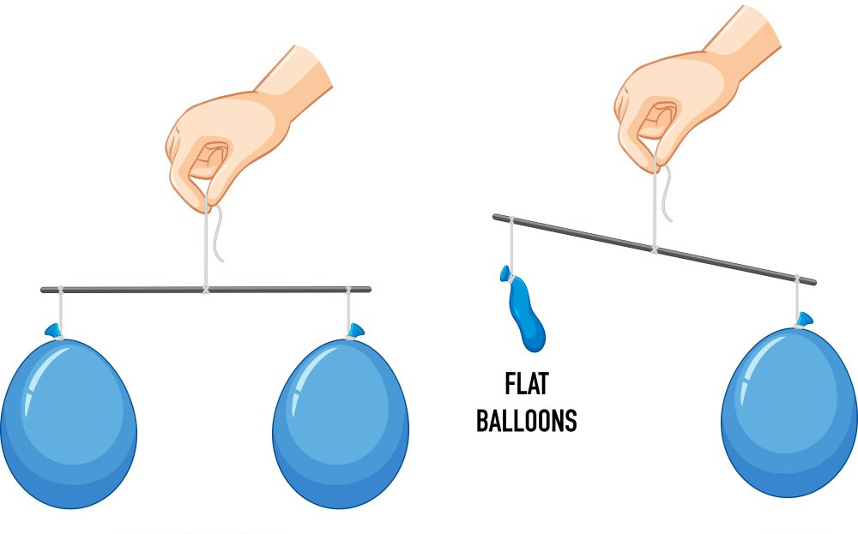

________________________________________________________________________

________________________________________________________________________

28. What is the use of a granary to farmers?

________________________________________________________________________

________________________________________________________________________29. Write down one way of controlling soil erosion.

________________________________________________________________________

________________________________________________________________________

30. What scientific name is given to the part of a flower shown below?

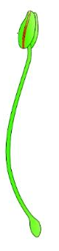

________________________________________________________________________

31. Name one breeding place for mosquitoes.

________________________________________________________________________

32. What are leguminous plants?

________________________________________________________________________

________________________________________________________________________

33. Suggest one reason why people iron their clothings and beddings.

________________________________________________________________________

________________________________________________________________________

34. Name one part of the human body used for feeling.

________________________________________________________________________

35. What name is given to the animals that live in the bush?

________________________________________________________________________

36. What is crop rotation?

________________________________________________________________________

________________________________________________________________________

37. Write any one component of soil.

________________________________________________________________________

38. Give any one cause of accidents on roads.

________________________________________________________________________

________________________________________________________________________

39. Name the young one of a dog.

________________________________________________________________________

40. Mention one example of a root tuber.

________________________________________________________________________

**SECTION B (60 marks)**

(*Each question carries 4 marks*)

41. **Study the diagram below and answer the questions that follow.**

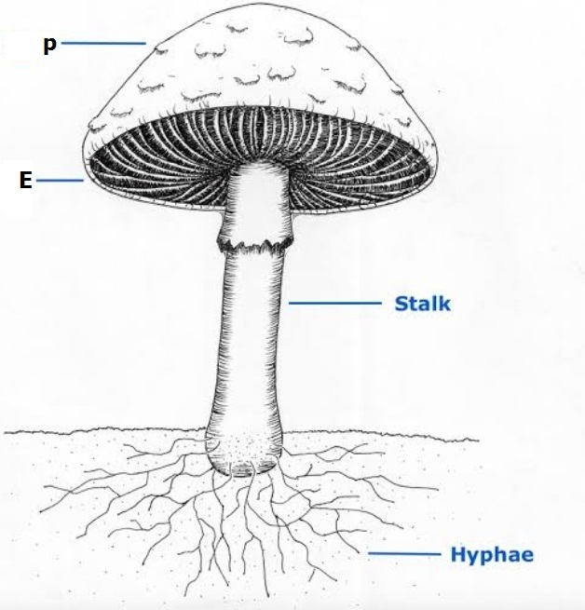

(a) Name the parts marked **P** and **E**

(i) **P** _________________________________________________________________

(ii) **E** _________________________________________________________________

(b) Of what use is part marked **P** to the plant?

___________________________________________________________________

___________________________________________________________________

(c) Give one economic importance of the above plant to man.

___________________________________________________________________

___________________________________________________________________

42. (a) What do you understand by the term transpiration?

___________________________________________________________________

___________________________________________________________________

(b) State one factor affecting the rate of transpiration.

___________________________________________________________________

___________________________________________________________________

(c) Identify two values of transpiration to plants.

(i) ___________________________________________________________________

___________________________________________________________________

(ii) ___________________________________________________________________

___________________________________________________________________

43. (a) What is soil?

___________________________________________________________________

___________________________________________________________________

(b) What term is used to describe the vertical arrangement of soil layers?

___________________________________________________________________

(c) Why should farmers keep soil fertile?

___________________________________________________________________

___________________________________________________________________

(d) Which type of soil is commonly used by potters?

___________________________________________________________________

44. (a) What is rabbitary?

___________________________________________________________________

___________________________________________________________________

1. Write down two examples of exotic breeds of rabbits.
2. __________________________________________________________________
3. _________________________________________________________________
4. What name is given to the house of a rabbit?

__________________________________________________________________

45. (a) Differentiate between air and wind.

___________________________________________________________________

___________________________________________________________________

1. What component of air is needed for photosynthesis to take place at night?

__________________________________________________________________

(c) Mention two uses of a wind mill.

(i) ___________________________________________________________________

(ii) ___________________________________________________________________

___________________________________________________________________

46. **Use the diagram below to answer the questions that follow.**

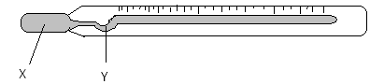

(a) What is the name of the diagram shown above?

___________________________________________________________________

(b) Identify the liquid labelled **X**.

___________________________________________________________________

(c) Name the part marked **Y.**

___________________________________________________________________

(d) Give one reason why the liquid labelled **X** is used in that instrument.

___________________________________________________________________

___________________________________________________________________

47. What part do we eat from each of these plants?

(a) onions _____________________________________________________________

(b) cassava___________________________________________________________

(c) sugarcane __________________________________________________________

(d) turmeric ____________________________________________________________

48 **Study the vectors below and match them with the diseases they spread.**

Lice Bubonic plague

Tiger mosquito Trachoma

Rat fleas Bilharzia

Houseflies Typhus fever

Yellow fever

(a) Lice _______________________________________________________________

(b) Tiger mosquito ___________________________________________________

(c) Rat fleas ________________________________________________________

(d) Houseflies ________________________________________________________

49. (a) Who is a dehydrated person?

___________________________________________________________________

___________________________________________________________________

(b) Give two ways of treating a dehydrated person.

(i) ___________________________________________________________________

___________________________________________________________________

(ii) ___________________________________________________________________

___________________________________________________________________

(c) How can we avoid getting dehydrated?

___________________________________________________________________

___________________________________________________________________

50. (a) Give one example of a metal you know.

___________________________________________________________________

(b) Mention two conditions that are needed for a metal to rust.

(i) ___________________________________________________________________

(ii) ___________________________________________________________________

(c) Outline any one way we can prevent metals from rusting.

___________________________________________________________________

51. **The diagram below shows a cross section through a maize grain. Study and use it to answer questions that follow.**

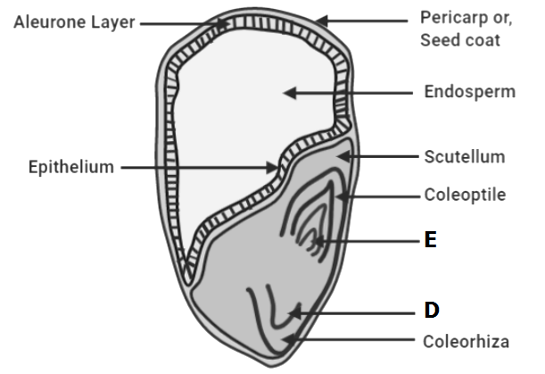

(a) Name the parts marked **D** and **E**.

(i) **D** ______________________________________________________________

(ii) **E** ______________________________________________________________

(b) What does part **E** develop into?

___________________________________________________________________

52 (a) Name the two types of pollination.

(i) ___________________________________________________________________

(ii) ___________________________________________________________________

(b) Identify any one agent of pollination.

___________________________________________________________________

(c) How are bees helpful to a farmer?

___________________________________________________________________

___________________________________________________________________

53. List any four elements of a clean home.

(i) ___________________________________________________________________

(ii) ___________________________________________________________________

(iii) ___________________________________________________________________

(iv) ___________________________________________________________________

54. **Below is a life cycle of an insect. Study it and answer the questions that follow.**

**Egg** **X**

**Adult**

(a) Name the stage labelled **X**.

___________________________________________________________________

(b) Give two examples of insects which undergo the lifecycle shown above.

(i) ___________________________________________________________________

(ii) ___________________________________________________________________

(c) Name one useful insect.

___________________________________________________________________

55. (a) What is mulching?

___________________________________________________________________

___________________________________________________________________

(b) Mention two advantages of mulching.

(i) ___________________________________________________________________

___________________________________________________________________

(ii) ___________________________________________________________________

___________________________________________________________________

(c) How does mulching improve on soil fertility?

___________________________________________________________________

___________________________________________________________________

***Good luck***

**P.4 Science 2024**

1. Clinical thermometer
2. Tooth paste/water/soap/towels/tooth brush/comb/nail cutter
3. Soil/stone/table/pens/books/etc
4. By camouflaging/By changing its colours to that of its surroundings.
5. Plants make their own food while animals have to look for their food.
6. plumule
7. It is used to put out fire.
8. Combing hair/cutting finger nails short/checking pupils’ personal hygiene.
9. Trachoma/dysentery/cholera/diarrhoea
10. To protect itself from enemies
11. Nimbus clouds give farmers rain.
12. To remove germs.
13. Cabbages/onions
14. Gills produce spores/store spores
15. The petals
16. Pinnate venation
17. By means of spores.
18. To collect nectar
19. Vitamin C
20. By throwing waste matter in it/Throwing rubbish in it/By grazing animals near it.
21. Sunken eyes/Dry lips/pale skin/little or no urine at all/A pinch on a skin goes back slowly.
22. Spiracles
23. Primary Health Care
24. To prevent bad smell /To chase away flies.
25. To look for food/For security/to find metes/For shelter.
26. By watering them/By weeding/By spraying/Mulching/Adding manure
27. Air has weight.
28. To store/keep harvested crops.
29. By terracing/contour ploghing/strip-cropping/Afforestation
30. Stamen
31. Stagnant water
32. Plants which have root nodules
33. To kill germs/To look smart
34. The skin
35. Wild animals
36. Crop rotation is the growing of different types on the same piece of land season after season.
37. Humus/water/air/living organisms
38. Bad roads/overspeeding/lack of road signs/vehicles in dangerous mechanical condition.
39. Puppy
40. Carrot/cassava/Yam/sweet potato.
41. –
42. P – cap E – gills
43. Part P produces and stores spores.
44. People sell the plant to get income.
45. –
46. Transpiration is the process by which plants lose water to the atmosphere through leaves.
47. Size of the leaves/Temperature/ Humidity
48. Cools the plant/plant sucks more water and mineral salts from the soil/ Accelerates growth through rapid water intake.
49. –
50. The top layer of the earth in which plants grow.
51. Soil profile.
52. In order to get high yields.
53. Clay
54. –
55. Rabbitary is the rearing or keeping of rabbits.
56. California/Angora/New zealand white/ chinichilla
57. hutch
58. –
59. Air is a mixture of gases while wind is moving air.
60. Carbon dioxide.
61. Pumping water from underground/ producing electricity.
62. –
63. Clinical thermometer
64. Mercury
65. Kink/bend
66. Liquid X is used because it does not stick on the walls/It expand and contracts easily.
67. –
68. Leaves
69. Roots
70. Stem
71. stem
72. –
73. Lice- Typhus fever
74. Tiger mosquito – yellow fever
75. Rat fleas – bubonic plague
76. Houseflies - trachoma
77. –
78. A person who does not have enough water in the body.
79. Giving the patient ORS/Giving the patient a lot of juice.
80. By taking plenty of water/By drinking a lot of juice.
81. –
82. Copper/Iron/Bronze/Brass/steel/ Aluminium
83. Oxygen/Water
84. By oiling/greasing/painting/enameling
85. –
86. D – Radicle E – Plumule
87. Root system
89. Cross pollination/Self pollination
90. Insects/wind/birds
91. Bees help to pollinate flowers for better yields.
92. –

Latrine(toilet)/Bathroom/Kitchen/ Rubbish pit

1. –
2. Nymph
3. Cockroach
4. Crickets/Grasshoppers/Termites
5. Grasshoppers
6. –
7. The covering of soil with dry grass.
8. Improves on soil fertility/Controls soil erosion/Controls the growth of weeds/Adds to humus after it decays.
9. By adding to humus and controlling moisture loss.